Final Project- 71269

Yonatan Schwartz and Raz Shenvald

**Introduction**

The subject of this project is the integrated pest management (IPM) of the leafhopper (*Orosius orientalis)*. who causes significant damage to sesame crops through its sap-sucking habits and its role as a vector for Phyllody disease. By eating the plant sap, both nymphs and adults induce curling of leaf edges, leaf discoloration, and premature leaf shedding, which weaken the plants and reduce their photosynthetic capability. More critically phyllody disease transforms floral parts into green leaf-like structures which cause severe yield losses ranging from 34% to 100%. Effective management of this pest is essential to protect sesame crop health and productivity.

Therefore, we propose a model to optimize the control of the leafhopper population on sesame crops while minimizing economic costs.

**Model**

1. Variables and parameters:  
   - **Population dynamics of leafhopper:** birth and pesticide effect.  
   - **Sesame crop characteristics:** market value, yield, damage taken.  
   - **Pesticide efficiency -** chemical, biological, and IPM (combined) - **Economic factors:** costs of damage, pesticides, and applications.
2. Objective function:  
   Minimize the total cost of pest management, including the costs of pesticide prices, applications, and economic losses due to leafhoppers. Financial losses are calculated based on the reduction in seeds by 10 leafhoppers per plant, infestation, and the average value of the sesame crop for oil.
$$minimize Total Cost= \sum_{t=0}^{weeks-1}{}(damages (t)+treatment costs(t))$$

3. Constraints:   
   - **leafhopper population dynamics:** considering only birth, carrying capacity of 10,000, and the impact of pesticide applications.   
   - **Constant market value and costs:** The market value of sesame and the pesticide costs remain the same throughout the season.  
   - **Pesticide application limits:** only once a week.  
   -**Homogeneity:** Regarding soil quality, climate conditions, leafhopper distribution, and pesticide application are all homogeneous in the field.  
   - **Pesticide resistance =** none**.**

Variables definitions

$$r= Reproduction rate= 4 times per week \\ K = Carrying capasity= 10,000$$

$$E_{c}= chemical pesticide efficiency=85\%$$

$$E_{b}= biological pesticide efficiency =70\%$$

$$E_{comb}=IPM efficeicy=95\%$$

$$k= Yield loss= 1.5 planet per 10 leafhopers$$

$$C_{c}= Chemical pesticide cost= 6 \$ per treatment$$

$$C_{b}=Biological pestiside's cost= 7.35 \$ per treatment$$

$$C_{comb}=IPM pestiside's cost= 6.675 \$ per treatment$$

$$P= Sesame's Market price= 2.4 \$ per kg \\ C_{d}= 0.048 \$ per damaged plant$$

$$C_{p}= Cost of pesticise application = 10 \$ per hour$$

1. Equations and developing Variables :

**Population dynamics:**

$$r= reproductive rate=4 times each week$$

$$K=carrying capacity =10,000$$

$$E_{c}= chemical pesticide efficiency= 0.85\%$$

$$E_{b}= biological pesticide efficiency =0.7\%$$

$$E_{comb}=IPM efficeicy=0.95\%$$

$$pop (t)=population(t-1)+r⋅population(t-1)⋅(1-\frac{population(t-1)}{K})-E_{i}(population(t-1)$$

**Sesame’s market value:**

As observed in the first weeks of the sesame season, in the plots of Professor Tzvika Peleg's research laboratory, we have estimated that each plot suffers a total loss of 1.5 plants. this disease requires the removal of these plants. Additionally, after counting dozens of samples, we found that, on average, there are 60 pods per plant, each containing about 70 seeds. This means that 1.5 plants represent an average loss of 6,300 seeds. Converting this to weight results in a loss of 20 grams of dry matter (ready seeds) per plant. There are 450 plots in the field, resulting in an estimated total loss of 9 tons of seeds. Given the average market price of sesame seeds (2.4 dollars per kg), the estimated loss amounts to 21,600 dollars for the first week and 0.048 dollars per damaged plant.

**Pesticide application and costs:**

Chemical- Based on professional experience, observations, and different resources, we found that the average concentration for using chemical pesticides is 2.5 ml when 30 ml of the substance is required for 12 liters of water (the volume of the sprayer). The pesticide market price stands at 34$ per liter. One sprayer takes about 30 minutes to operate, with the labor cost being $10 per hour. Consequently, we calculated that a single treatment costs $6.

Biological- Based on the same assumptions as above, we found that a single biological treatment requires an average of 300 grams of material. The pesticide cost is $22 per kilogram, resulting in a single treatment cost of $7.25.

Combined- Assuming that an integrated pest management treatment is evenly divided between the types of treatments, the cost of a single such treatment would be $6.675.

based on articles, research, and assumptions we found that 10 leafhoppers cause irreversible damage to 1.5 plants.

Yield loss due to leafhopper

$Yield loss=\sum_{t=0}^{weeks-1}{}(\frac{pop(t)}{10}⋅k)$

Total loss of damage $T_{d}=\sum_{t=0}^{weeks-1}{}((\frac{pop(t)}{10}⋅k⋅C_{d})$

Z= Total cost of IPM $Z=\sum_{t=0}^{weeks-1}{}((\frac{pop(t)}{10}⋅k⋅C_{d})+{C_{i})}_{}$

**Results**

graph 1-

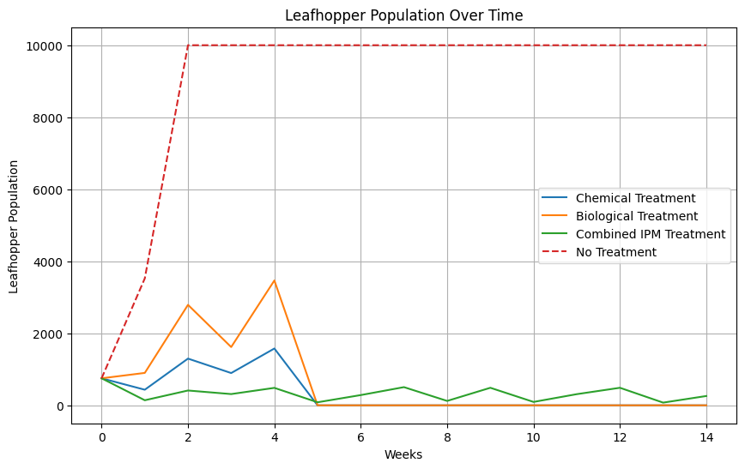

This graph shows the changes in population size over 15 weeks depending on the type of pesticide treatment. On week 5, biological and chemical treatment brought the population to extinction, although the combined treatment didn’t extinct the leafhopper’s population. The control graph (no treatment) seen escalating quickly due to the leafhopper’s rapid reproduction.

graph 2-

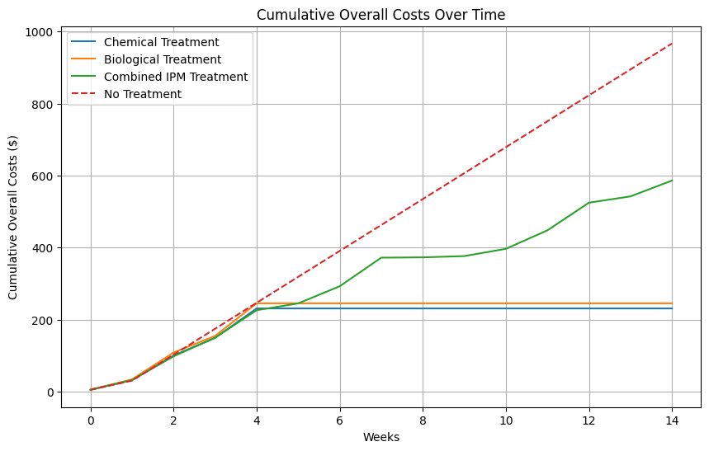  
This graph shows the total costs as a function of the number of weeks for each treatment. In week 4, biological and chemical treatments reached a plateau due to the population's extinction when the combined treatment continued to grow at different paces. No treatment graph demonstrates the potential money loss.

graph 3-

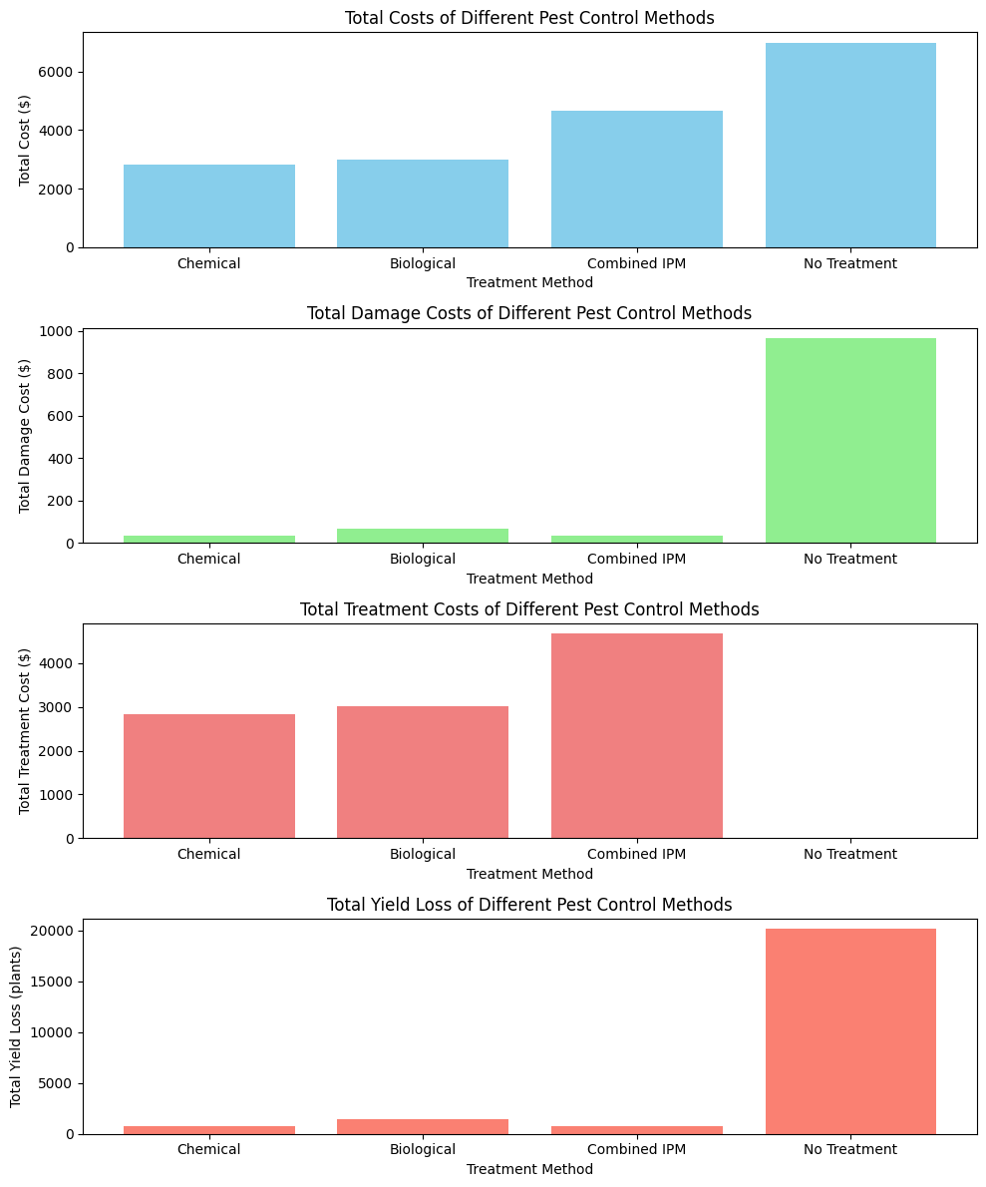

This fig. is divided into four parts, each showing a different component of

the total costs for the three treatments. from up to bottom total costs, damage  
 costs, treatment costs, and yield loss.

graph 4-

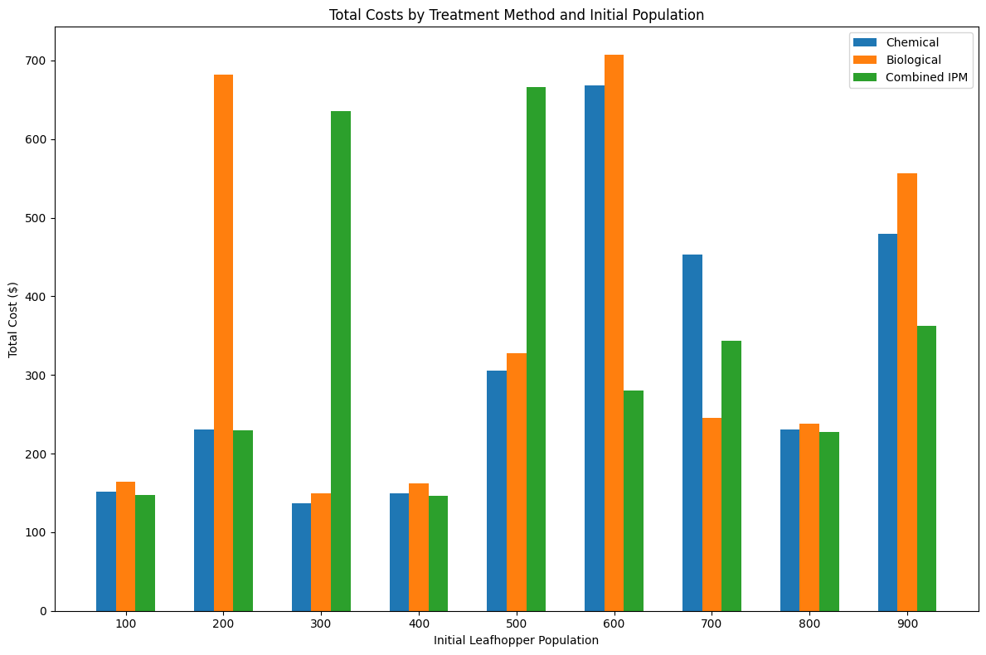

Graph 4 shows the total costs of each treatment method as a function of the initial leafhopper population size. The data highlights that no single treatment is consistently preferred over the others when the initial population changes. Instead, the preferred treatment varies depending on the initial population, with significant cost differences between treatments at various population sizes.

**Conclusions**

**Cost Efficiency-** The combined IPM treatment incurs the highest total costs compared to chemical and biological treatments. Despite its effectiveness in controlling leafhopper populations, its higher treatment costs make it less cost-efficient for growers with budget constraints. The chemical treatment shows a steady accumulation of costs, while the biological treatment has slightly higher overall costs but remains more affordable than the combined IPM treatment.

**Damage Costs-** The biological treatment results in the highest damage costs, indicating that while it may be less expensive in terms of treatment, it leads to more significant crop damage. The chemical treatment has moderate damage costs, making it a more balanced option. The combined IPM treatment, despite its high treatment costs, minimizes damage costs, thus protecting the crop better.

**Population Control-** The combined IPM treatment is the most effective at maintaining a low and consistent leafhopper population over time. The chemical and biological treatments both show fluctuations in population size, with the biological treatment experiencing the highest peaks. Therefore, for effective population control, the combined IPM treatment is superior.

**Impact of Initial Population-**  The initial population size significantly affects the total cost-effectiveness of each treatment. There is no single treatment that is consistently the most cost-effective across different initial population sizes. The choice of treatment should therefore consider the initial infestation level, as different treatments become more advantageous at various population sizes.

In summary, while combined IPM is the most effective in controlling leafhopper populations, its high cost may not be justifiable for all growers. Chemical treatments offer a balanced approach with moderate costs and damage, whereas biological treatments, despite lower upfront costs, may lead to higher damage and yield loss. Therefore, the choice of treatment should be guided by both economic considerations and the specific conditions of the infestation.

An article supporting our model

1. Rao, G. P., S. Un Nabi, and Madhupriya. "Overview on a Century Progress in Research on Sesame Phyllody Disease." *Phytopathogenic Mollicutes* 5, no. 2 (2015): 74-83. doi:10.5958/2249-4677.2015.00064.X.
2. Borkar, Sundar, Navya Matcha, Duraimurugan Ponnusamy, and M. Surya Prakash Reddy. "Sucking Pests of Oilseed Crops." .2020. .
3. Singh, Devendra Pal, ed. *Integrated Pest Management in Diverse Cropping Systems*. 1st ed. Palm Bay, FL, USA: Apple Academic Press, 2023.
4. Zakarya, Yasser M., Mohamed M. Metwaly, Mohamed A. E. AbdelRahman, Mohamed R. Metwalli, and Georgios Koubouris. "Optimized Land Use through Integrated Land Suitability and GIS Approach in West El-Minia Governorate, Upper Egypt." *Sustainability* 10, no. 3 (2021): 803. doi:10.3390/su10030803.
5. Horowitz, A. Rami, and Isaac Ishaaya, eds. *Advances in Insect Control and Resistance Management*. Springer International Publishing, 2016. doi:10.1007/978-3-319-31800-4